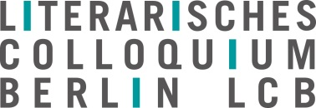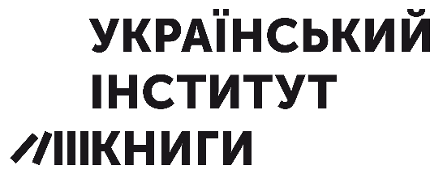
Archipel U
International meeting of Translators of Ukrainian Literature
Literarisches Colloquium Berlin, 25 – 29 August 2024
Application form (to be completed preferably in English, also possible in German or Ukrainian)

Name:

Date of birth:

Address:

E-mail:

Mobile phone number

Nationality:

Translating into which target language?

Profession/s:

Published translations (10 titles max.):

Short biography, career as a literary translator:

Some words about motivation, areas of interest, suggestions for the program of the meeting

